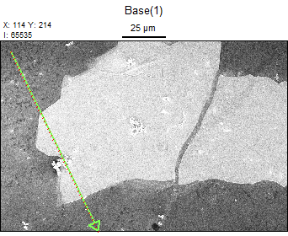

Accelerating Voltage: 5.0 kV

Magnification: 1300

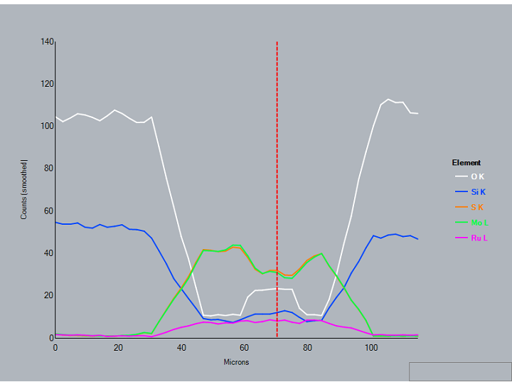

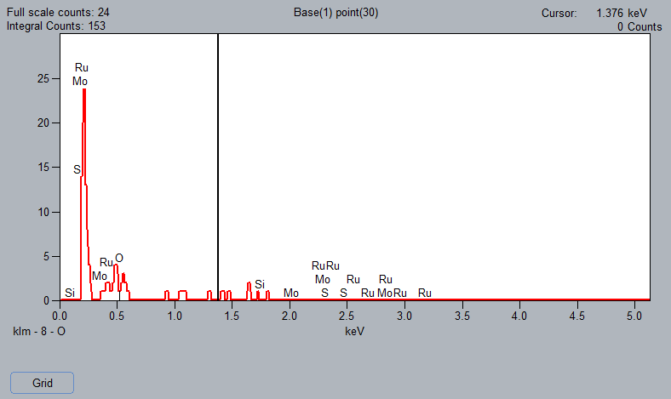

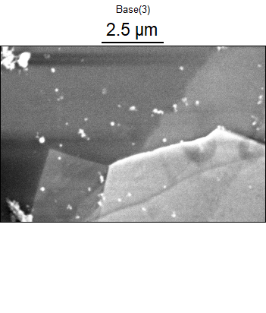

Data Type: Counts

Image Resolution: 1024 by 682

Image Pixel Size: 0.01 µm

Map Resolution: 512 by 340

Map Pixel Size: 0.02 µm

Acc. Voltage: 5.0 kV

Magnification: 20000

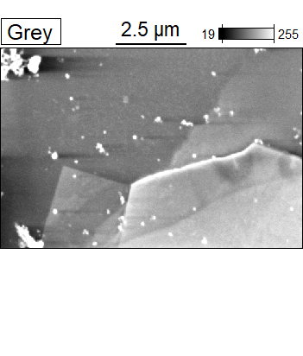 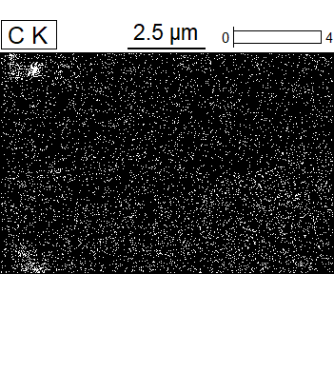



Data Type: Counts

Image Resolution: 1024 by 682

Image Pixel Size: 0.01 µm

Map Resolution: 512 by 340

Map Pixel Size: 0.02 µm

Acc. Voltage: 5.0 kV

Magnification: 20000

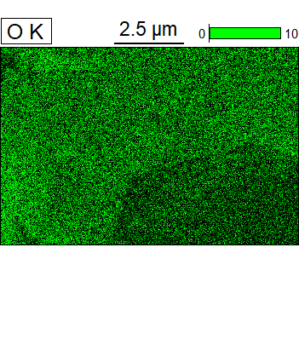 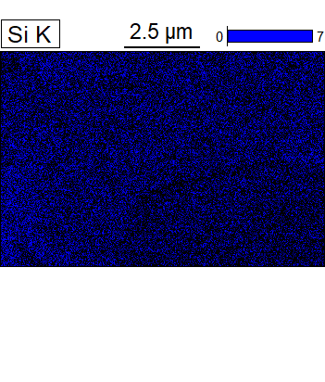



Data Type: Counts

Image Resolution: 1024 by 682

Image Pixel Size: 0.01 µm

Map Resolution: 512 by 340

Map Pixel Size: 0.02 µm

Acc. Voltage: 5.0 kV

Magnification: 20000

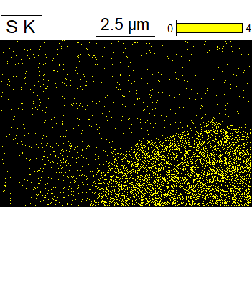 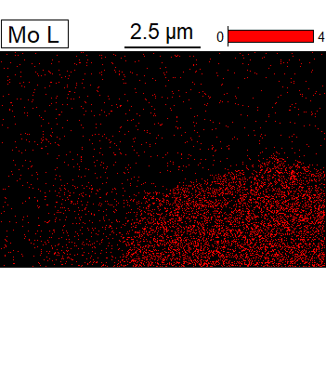



Data Type: Counts

Image Resolution: 1024 by 682

Image Pixel Size: 0.01 µm

Map Resolution: 512 by 340

Map Pixel Size: 0.02 µm

Acc. Voltage: 5.0 kV

Magnification: 20000

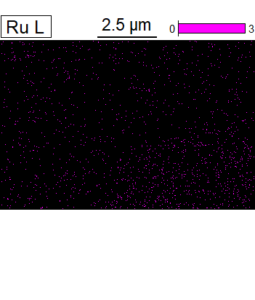



Data Type: Counts

Image Resolution: 1024 by 682

Image Pixel Size: 0.01 µm

Map Resolution: 512 by 340

Map Pixel Size: 0.02 µm

Acc. Voltage: 5.0 kV

Magnification: 20000

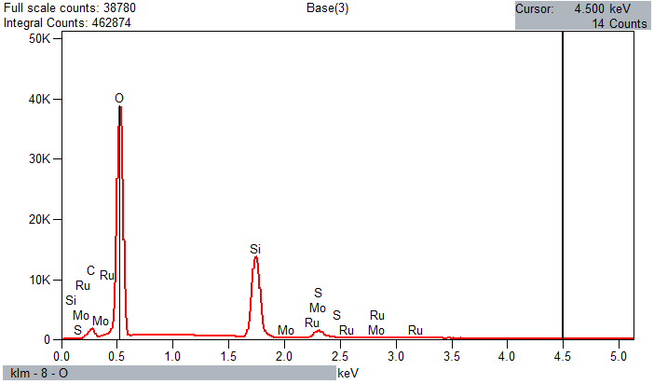

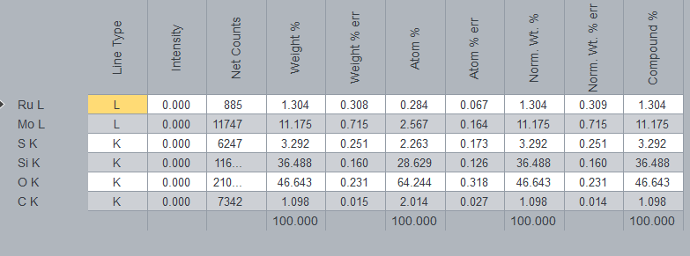

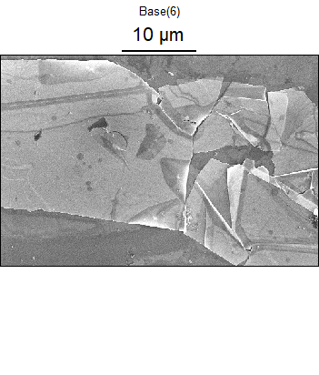

Data Type: Counts

Image Resolution: 512 by 340

Image Pixel Size: 0.08 µm

Map Resolution: 256 by 170

Map Pixel Size: 0.17 µm

Acc. Voltage: 25.0 kV

Magnification: 5000

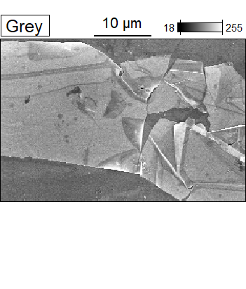 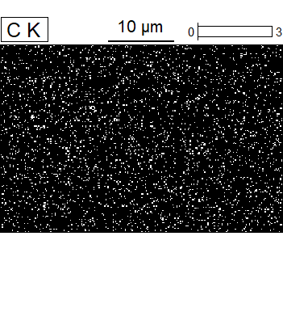



Data Type: Counts

Image Resolution: 512 by 340

Image Pixel Size: 0.08 µm

Map Resolution: 256 by 170

Map Pixel Size: 0.17 µm

Acc. Voltage: 25.0 kV

Magnification: 5000

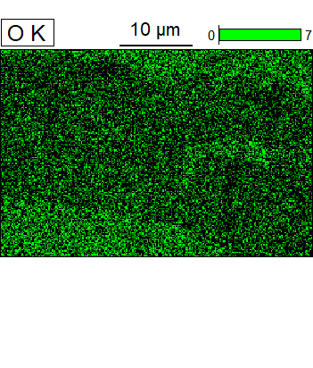 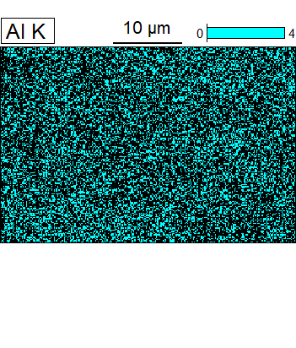



Data Type: Counts

Image Resolution: 512 by 340

Image Pixel Size: 0.08 µm

Map Resolution: 256 by 170

Map Pixel Size: 0.17 µm

Acc. Voltage: 25.0 kV

Magnification: 5000

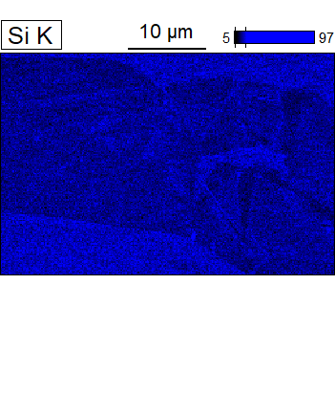 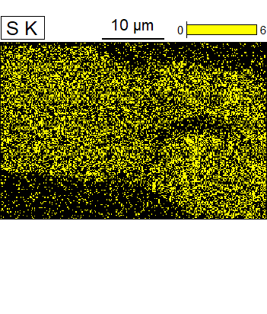



Data Type: Counts

Image Resolution: 512 by 340

Image Pixel Size: 0.08 µm

Map Resolution: 256 by 170

Map Pixel Size: 0.17 µm

Acc. Voltage: 25.0 kV

Magnification: 5000

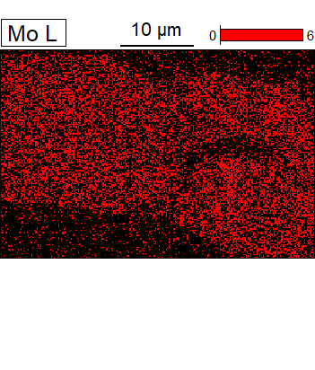 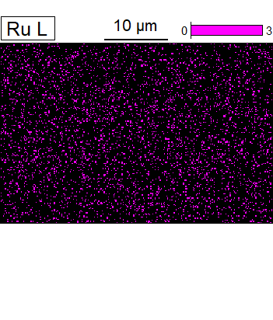



Data Type: Counts

Image Resolution: 512 by 340

Image Pixel Size: 0.08 µm

Map Resolution: 256 by 170

Map Pixel Size: 0.17 µm

Acc. Voltage: 25.0 kV

Magnification: 5000

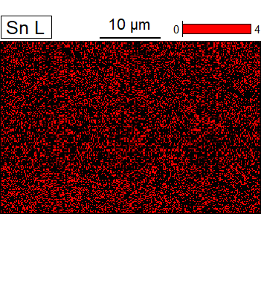



Data Type: Counts

Image Resolution: 512 by 340

Image Pixel Size: 0.08 µm

Map Resolution: 256 by 170

Map Pixel Size: 0.17 µm

Acc. Voltage: 25.0 kV

Magnification: 5000

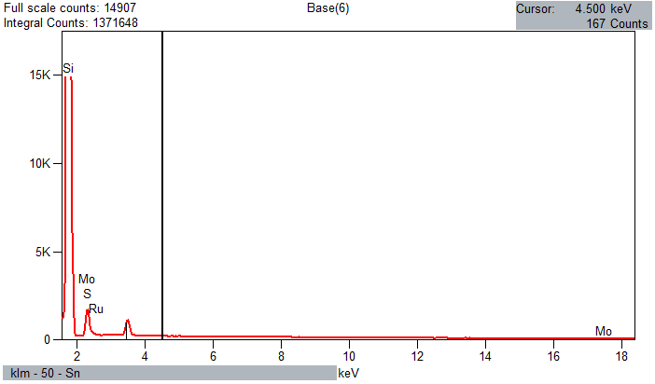

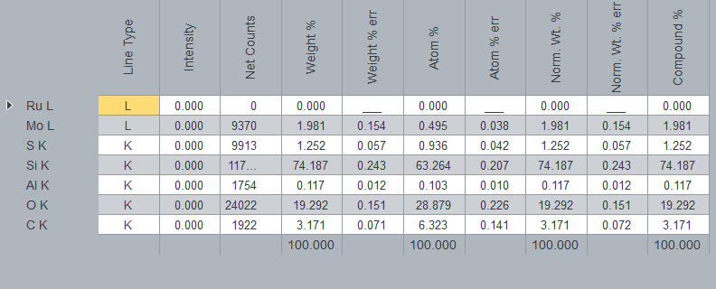

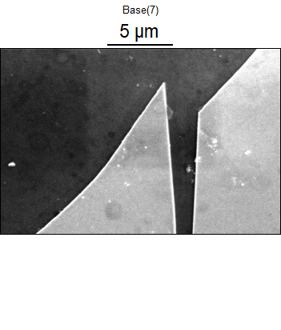

Data Type: Counts

Image Resolution: 1024 by 682

Image Pixel Size: 0.02 µm

Map Resolution: 256 by 170

Map Pixel Size: 0.08 µm

Acc. Voltage: 5.0 kV

Magnification: 10000

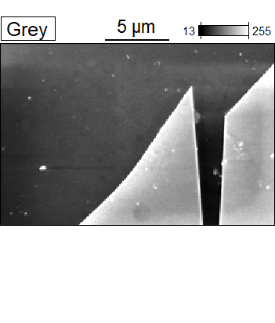 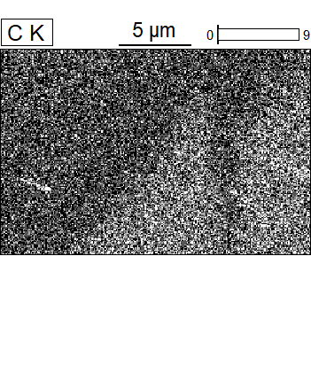



Data Type: Counts

Image Resolution: 1024 by 682

Image Pixel Size: 0.02 µm

Map Resolution: 256 by 170

Map Pixel Size: 0.08 µm

Acc. Voltage: 5.0 kV

Magnification: 10000

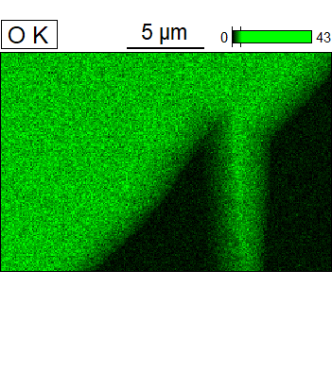 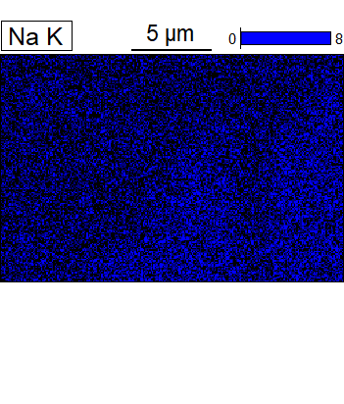



Data Type: Counts

Image Resolution: 1024 by 682

Image Pixel Size: 0.02 µm

Map Resolution: 256 by 170

Map Pixel Size: 0.08 µm

Acc. Voltage: 5.0 kV

Magnification: 10000

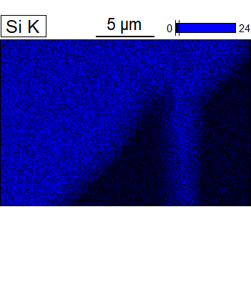 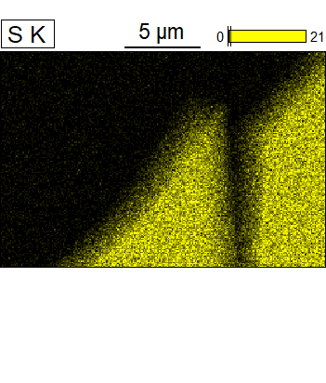



Data Type: Counts

Image Resolution: 1024 by 682

Image Pixel Size: 0.02 µm

Map Resolution: 256 by 170

Map Pixel Size: 0.08 µm

Acc. Voltage: 5.0 kV

Magnification: 10000

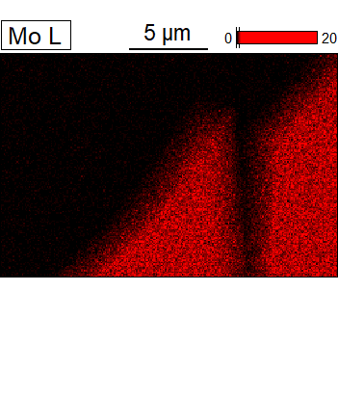 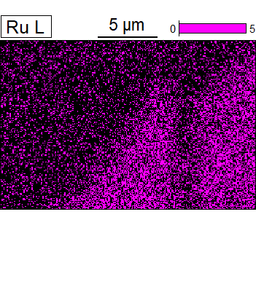



Data Type: Counts

Image Resolution: 1024 by 682

Image Pixel Size: 0.02 µm

Map Resolution: 256 by 170

Map Pixel Size: 0.08 µm

Acc. Voltage: 5.0 kV

Magnification: 10000

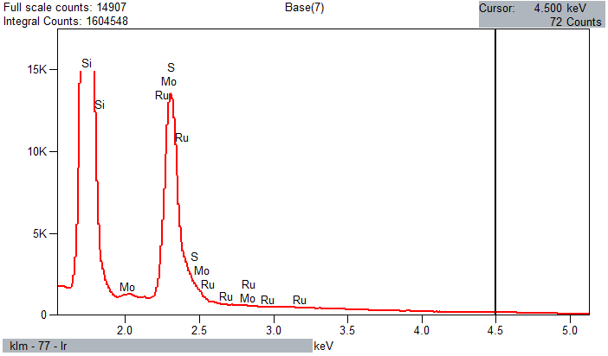

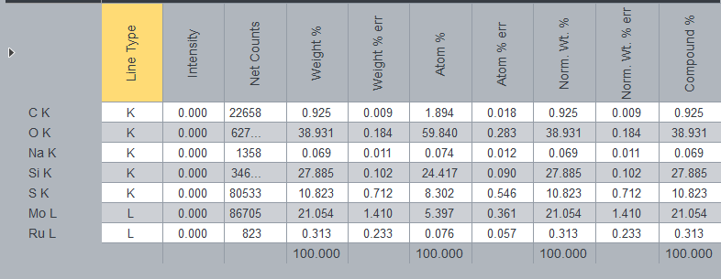

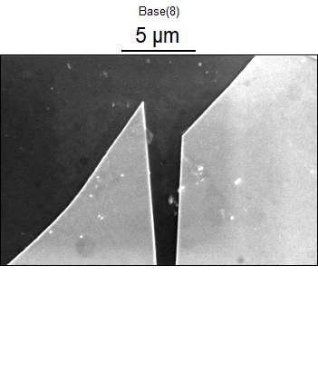

Data Type: Counts

Image Resolution: 1024 by 682

Image Pixel Size: 0.02 µm

Map Resolution: 256 by 170

Map Pixel Size: 0.08 µm

Acc. Voltage: 5.0 kV

Magnification: 10000

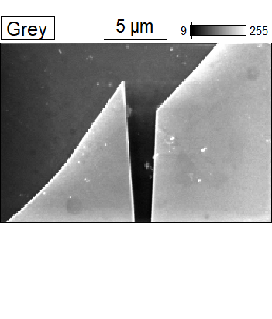 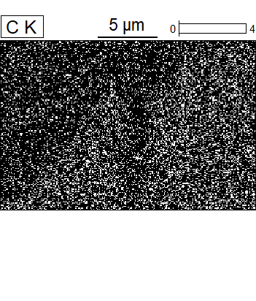



Data Type: Counts

Image Resolution: 1024 by 682

Image Pixel Size: 0.02 µm

Map Resolution: 256 by 170

Map Pixel Size: 0.08 µm

Acc. Voltage: 5.0 kV

Magnification: 10000

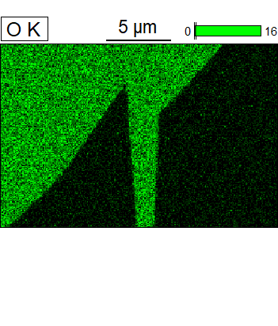 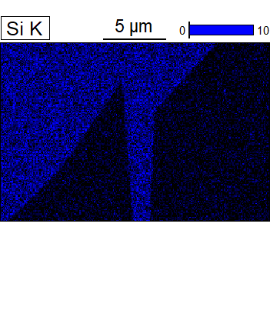



Data Type: Counts

Image Resolution: 1024 by 682

Image Pixel Size: 0.02 µm

Map Resolution: 256 by 170

Map Pixel Size: 0.08 µm

Acc. Voltage: 5.0 kV

Magnification: 10000

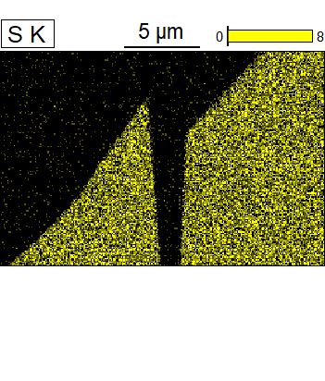 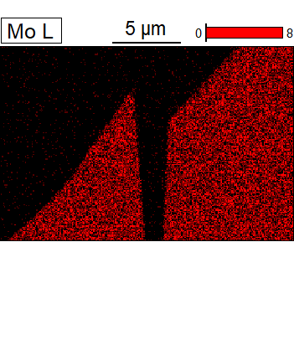



Data Type: Counts

Image Resolution: 1024 by 682

Image Pixel Size: 0.02 µm

Map Resolution: 256 by 170

Map Pixel Size: 0.08 µm

Acc. Voltage: 5.0 kV

Magnification: 10000

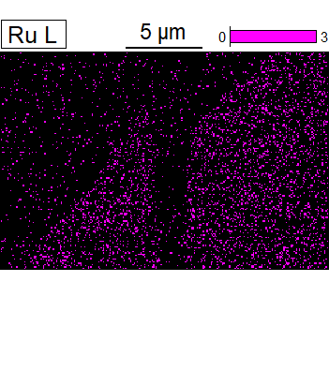



Data Type: Counts

Image Resolution: 1024 by 682

Image Pixel Size: 0.02 µm

Map Resolution: 256 by 170

Map Pixel Size: 0.08 µm

Acc. Voltage: 5.0 kV

Magnification: 10000

